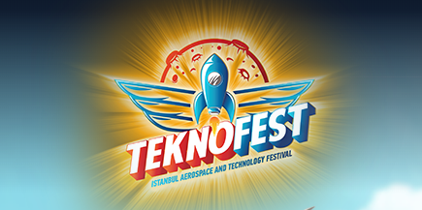

TEKNOFEST 2019 Technology Competition Applications Are Now Opened!

TEKNOFEST in its first year, has managed to be the best aviation and technology activity not only in Turkey but in the region, too. Last year, TEKNOFEST has more than 550 thousand participants which has included 700 competitor teams, drone racers from 25 countries, white hat hackers from 24 countries and other technology enthusiasts from 83 different countries. This year also the applications are open for the teams from abroad.

You can visit the following link for TEKNOFEST 2018:

<https://youtu.be/g8z5keQcV6Y>

Application Deadline for the Technology Competitions including many different areas from Artificial Intelligence to Flying Cars, from Autonomous Systems to Space Technologies with awards of more than 2 Million TRY is March 31, 2019.

As representatives of the Turkish Tech Team Foundation, it is our pleasure to inviting you to the competitions which will be held within the scope of TEKNOFEST 2nd Annual TEKNOFEST Aerospace and Technology Festival, to be held in Turkey's largest annual technology convention this September in Turkey.

The competitions come as part of the TEKNOFEST, a space and technology festival organized by the Turkish Technology Team Foundation (T3 Foundation) in partnership with our Ministry, the Under secretariat for Defense Industries of Turkey, and other stakeholders from private and public sectors.

Competitions in 16 different categories are organized for supporting youth's interest within future technologies in the scope of TEKNOFEST, which aims to create technology and science awareness in the whole society and increase trained human resources in the fields of science and engineering.

**The competitions to be held within the scope of TEKNOFEST 2019 are as follows:**

**Primary, Middle, High School and Higher Education:**

Smart Places Hackathon Competition

Technologies for Humanity Competition

Flying Car Design Competition

**High School, Undergraduate and Graduate Level:**

Unmanned Underwater Systems Competition

Rocket Competition

Robotics Competitions

Fighter UAV Competition

Artificial Intelligence Competition

Robotaxi (Full Scale Autonomous Vehicle) Competition

**Undergraduate and Graduate Level:**

Efficiency Challenge Competition

Unmanned Aerial Vehicle Competition

Satellite Model Competition

Mini Jet Radial Compressor Design Competition

Turbofan Motor Design Competition

Swarm UAV Simulation Competition

**Winners will be awarded with the final prize over 2 million TL in total. Furthermore, Accommodation and Transportation support will be provided for successful finalist teams.**

Visit <https://www.teknofestistanbul.org/en> for details and applications till **March 31, 2019**.

The Teknofest Organizing Committee

Turkish Technology Team Foundation

Republic of Turkey

Point of Contact: +90 212 501 94 34| [iletisim@teknofestistanbul.org](mailto:iletisim@teknofestistanbul.org)

